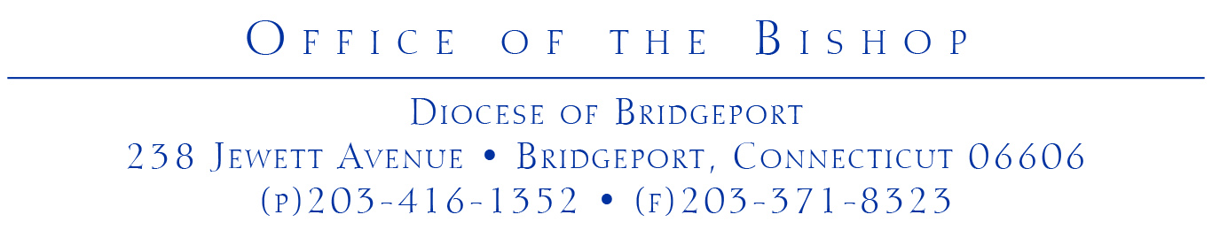

To: All Clergy and Diocesan Officials

From: Bishop Frank J. Caggiano

Re: COVID-19 (Coronavirus) Update

Date: March 13, 2020

As you know, many throughout Fairfield County – both Catholics and non-Catholics – look to the Church for leadership, especially in moments like the one we are currently facing. It is important that we, as a Catholic community of faith, remain faithful to who we are and place the celebration of the Eucharist and trust in the Lord at the forefront of all decisions. At the same time, we are also members of a larger community and have a duty to abide by civil regulations and be co-responsible in seeking the common good.

Being situated in Fairfield County, we must be especially cognizant of the unique situation we face in regard to the Coronavirus. The southern part of the Diocese neighbors Westchester County, New York, which has seen numerous outbreaks of the illness, and many of our lay faithful travel to and from New York City on a daily basis or travel to foreign countries for business. Furthermore, our County has a growing population of elderly citizens, and several cases of Coronavirus have already been identified here, most significantly the case in New Canaan, which is the first reported case of communal transmission in the State of Connecticut.

Above any practical decisions made due to the Coronavirus, I would like to remind all of us to place all of our trust in the Lord, “who made Heaven and earth,” and to seek His help, healing and protection. This is a time, especially for those of us consecrated to the Lord, to lead by an example of confidence in His providential care and of charity to those who are in need. We should rely on all the spiritual tools we have – including the Rosary, votive Masses for times of special need, devotions – and beg for an end to this illness here and throughout the world.

In that spirit, and given the developments over the last week, I would like to inform you of some new directives that will be binding throughout the Diocese of Bridgeport.

Parishes

In my Memo on March 9, 2020, I asked you to inform your parishioners that anyone exhibiting flu-like or cold symptoms, the elderly and those with underlying physical conditions that would make them more susceptible to the Coronavirus are not obliged to attend Sunday Mass. Beginning this Third Sunday of Lent (March 14-15) through the Fifth Sunday of Lent (March 28-29), I am temporarily dispensing all Catholics of the Diocese of Bridgeport from the obligation to attend Sunday Mass.

I am taking this action so that anyone who may be fearful of becoming ill or of spreading illness, especially healthcare workers, caregivers to the elderly or infirmed or parents with young children, may have peace of mind in knowing that, with this provision, they do not commit mortal sin if they choose not to attend Sunday Mass. For those who decide to refrain from attending Mass on the Sundays indicated above, I would ask that they treat the Lord’s Day with the honor it deserves and try, to the best of their ability, to view Mass online or to make time to read the Scriptures for the day.

In light of Governor Ned Lamont’s Executive Order of yesterday, which prohibits gatherings of 250 people or more throughout the State through the end of April, but makes an exemption for worship services, it may be the case that local authorities contact you to consider temporarily suspending the public celebration of Mass. Until then, there should be no changes to the public Mass schedule of any parish. Should that moment come, however, Pastors will be required to follow any ordinances or mandates published by legitimate local authorities, who have been entrusted to protect the community at large. Furthermore, if any future ban on public assemblies necessitates the suspension of public Mass, Pastors should see that all Mass intentions are fulfilled, and all priests would be expected to celebrate private Mass daily.

I also want to repeat my strong suggestion that non-liturgical, social events scheduled to take place in the immediate weeks ahead at parishes or diocesan institutions, especially those at which the elderly may be inclined to participate, be postponed or cancelled.

I ask all Pastors and leaders of institutions to inform the Office of the Bishop if you become aware of any major new mandates, significant decisions or closings in your respective towns of which the Diocese should be aware.

Diocesan Schools and Academies

Beginning today, Friday, March 13, 2020, all diocesan schools and academies will be closed for a period of two weeks. In most cases, this follows the decision of towns in Fairfield County that have already closed their public schools. Unless circumstances make it otherwise, all diocesan schools and academies will reopen on Monday, March 30, 2020. School leadership and parents were informed of this decision by their local Principals.

It should be noted that during this period students will continue to receive instruction through distance learning plans that were developed in the last two weeks by the Office of the Superintendent for just this circumstance.

Confirmations

Because Confirmations draw large crowds of people, some of whom come from other parts of the country, I have decided that it is most prudent to postpone all parish Confirmations that are scheduled to take place before Easter Sunday. My Office will work with the Pastors of the affected parishes to reschedule the Confirmations at a later date.

Catholic Center

As of today, all large (more than five people) meetings scheduled to take place at the Catholic Center have been postponed, cancelled or will be conducted via teleconferencing. Furthermore, it may be necessary at some point in time to significantly limit the number of people working at the Catholic Center for a defined period. Those who may be asked not to report to work at the Catholic Center will work from home as best as possible. If this reduction in on-site staffing becomes necessary you will be informed accordingly, and we will do our best to respond to the needs of all diocesan institutions.

Ongoing Communication

Beginning this Monday, March 16, 2020, I will, in collaboration with the Office of Communications, be sending regular updates on the impact of the Coronavirus on the daily life of the Diocese and the religious practice of its priests, religious and lay faithful. I ask that each one of you check your diocesan email each Monday, Wednesday and Friday for these important updates.

+ + +

I am grateful to all of you for your diligence and cooperation as the pandemic involving the Coronavirus continues to unfold. Your leadership and clear presentation of recent diocesan directives has helped to assure parishioners that the Church takes their health and well-being very seriously.

Be assured of my daily prayers.

